Project Plan Mind Manager App

Primary Instructor | Anjana Shah
Team Member | Bruna Bispo Abatepaulo
Team Member | Evgeniya Zhukova
Team Member | Gordon Wells
Team Member | Karin Zigdon
Team Member | Marina Savochkina

Document Revision History

Revision # | Date
#1 | 10/09/2020
#2 | 01/27/2021

Table of Contents
- Executive Summary 3
- Project Approvers, Reviews and Distribution List 3
- Scope 3
- Deliverables 4
- Assumptions 4
- Dependencies 4
- Risk Management 5
- Communication 6
  - Reporting 6
  - Meetings 6
- Task Listing (WBS – Work Breakdown Structure) 7
- Gantt Chart 7
- Milestones 8
- RAM – Responsibility Assignment Matrix 9
- Approval 9

Executive Summary
The following describes the project to be executed.

Objective | Create an application that will suggest to the users different activities based on their selected and designated moods.
Corporate Goals Addressed | Create a user-friendly and effective mobile application that meets the objectives that have been set out and meets all operational and legal criteria for functionality.
Planned Start Date | September 14th, 2020
Planned End Date | April 2nd, 2020

Project Approvers, Reviews and Distribution List

Approvers, reviewers and distribution list

Project Role | Name | E-mail | Date
Developer | Bruna  Bispo Abatepaulo | bruna.bispoabatepaulo@georgebrown.ca | 01/27/2021
Marketing Analyst | Evgeniya Zhukova | evgeniya.zhukova@georgebrown.ca | 01/27/2021
System Analyst | Gordon Wells | gwells2@georgebrown.ca | 01/27/2021
Software Support | Karin Zigdon | karin.zigdon@georgebrown.ca | 01/27/2021
Developer | Marina Savochkina | marina.savochkina@georgebrown.ca | 01/27/2021

Scope

In Scope | Out of Scope
The product will provide an interactive system that will be user-friendly and straightforward. It will not require any training on how to use the application. | If the user has some kind of disability or mental impairment, this would be beyond of the abilities of the application.
The product will help those people who do not know what to do when they are in some kind of mood. | Food and medical advice will not be included in the project.
The application will include:  - A login / registration page, where the user will be requested to login, or registrate, to be able to use the software features;  - a home page, where the user will be able to selects the different mood(s);  - a questionnaire page, where the user will be requested to answer a few questions (if the “I don’t know” button was pressed), to help the software decide what mood is best fitted for that user;  - a suggestions list, where the user will be presented with many suggestions based on the choices made previously;  - a profile page, which will be consisted of the user’s name and email address (at launch) | A feature in the profile page, where the user will be able to access past choices and suggestions lists (at launch).
The application will have an administrator access, so new activities and suggestions can constantly be updated.

Deliverables
This project will deliver the following.

Deliverable | Description
A mobile app in two versions (for Android and iOS) | The application will be available in two versions – one for Android and one for iOS. Both versions will have the same idea and generally the same implementation. Versions may differ in some specific details, since they will be executed in different development environments.
Two modes – admin and user | The application will be developed for two different roles - admin and user. The admin role will be provided with application administration functions such as managing lists of users and lists of suggestions, changing the content of the questionnaire, etc. The user role will be provided with user’s functions such as possibilities to respond to the questionnaire, to choose from the provided list of moods, to view user account, to act with the list of suggestions, etc.
Database | The application will be using a database to store information.
User friendly design | Application design will be user friendly and intuitively understandable.
Login Page (user and admin) | Page will be created in purpose to authorize a user into his/her account.
Registration page (user only) | Page will be made in purpose so the user can create a new account.
Forgot password page | Page will be created in purpose so the user can reset the password if needed.
Home Page / Mood selection page (user only) | First page after user authorization. The user will be able to select multiple moods that they associate to at that moment.
Questionnaire page (user only) | If the user does not identify with any of the presented moods, he/she will be able to answer a few questions, so the application can designate the user’s mood properly.
Activities suggestions page (user only) | The application will suggest various  activities to the user, according to the chosen mood(s). It will present several categories such as: Sport, Music, Reading, etc. and it will show one suggestion for each category.
Filter button on Activities suggestions page (user only) | With this filter, the user could choose which categories he/she would like to see and hide the ones he/she do not want to see (for example, choose to see only Book Category or several Categories such as Sport and Games)
Location Range / Map button on Activities suggestions page (user only) | Map button will present the user their current location and the user will be able to mark how far he/she is willing to go to implement the app's suggestions.
Randon Button on Activities suggestions page (user only) | With this button a user will be able to change a set of suggestions, if the previous set was not interesting for him/her.
Menu Page (admin only) | First page after admin authorization. It would be a page from where admin can decide what to do.
List of users (admin only) | List with information about users. Admin could do some operations with it such as edit or delete accounts.
Edit mood options (admin only) | Page where admin could add, edit, or delete mood options which will be available for user’s choice.
Edit questionnaire (admin only) | Page where admin could edit or delete questions from the questionnaire.
Edit categories and suggestions (admin only) | Page where admin could add, edit, or delete categories and its suggestions.

Assumptions
This project makes the following assumptions;

- The project will remain mostly focused on the creation of a mobile app. Any changes to the format of the deliverable will unlikely not change throughout the life of the product.
  - Any further additions to the projects in relation to any web-based functionality while discussed in previous reports, it was decided that it would not be applicable before the deadline of the project and would be an unnecessary resource sink at this time.
  - We project that, perhaps, a web-based addition to the project could be possible at some point in the future. But will not included for this project completion.
- The team will remain consistent from beginning to the end of the project with no members leaving or entering during its length
  - We base this in relation to the current group being at the maximum allowed in terms of group sizes. In this regard we would not be permitted to add another group member even if that were desired.
  - In addition, no current member of the project team has given any desire to retire from the project and given the current sprint that the project has commenced this does not seem likely to be going forward.

- The overall project document and deliverable will likely go through several revisions before the final document is chosen and submitted.
  - The project included many unknowns in regards to how its functionality would be implemented during the initial planning stages based on project members' limitations in experience in mobile-application creation. Therefore, as we began preliminary research, initial assumptions and initial project ideas will go through revisions considering new information.
  - In addition, due to the nature of the project, many different types of features could be added to the project that would not impact its core functionality (for example new gaming, or music features) thusly any ideas that are later debated upon may be added to the project if we feel it would improve the overall enjoyability of the final deliverable.

- No substantial increase in budget will be put towards the project and the team will make do with what equipment they have available.
  - As no official budget was given at the project's beginning, we have no reason to believe that any will be provided during the life of the project. Beyond the resources already provided to us at the beginning of project commencement.
  - We assume that should ever monetary resources be needed for the project; it will be provided by the project members themselves based on their own discretion and willingness to denote to the project.
  - However, we do assume that should monetary resources be needed, this will be discussed with each project member before any decision on what these resources should be spent on. In addition to who would be donating the funds and how.

Dependencies
The following are the internal and external dependencies that will have to be acknowledged and addressed;

Internal Dependencies
- Proper interpersonal collaboration between the development team.
  - Due to different time zones and scheduling constraints, proper time management will be essential, especially when scheduling meetings.

- Budget
  - Currently, there is no official budget for this project
  - The team members will provide funds if necessary
- Coding skills
  - All team members have a good understanding on programming applications, however there are some topics and languages that the team are not comfortable with (e.g., SQLite and Swift Programming Language).

External Dependencies
- User preferences and general consumer taste could change to the product’s detriment, leading to the lack of consumer interest.

Risk Management

Potential Risk | Severity(H/M/L) | Likelihood(H/M/L) | Management Strategy
Lose contact with a team member in foreign country | H | L | To prevent loss of contact each member provides multiple contact methods that they can be reached (email, phone, WhatsApp, skype, etc.)
Potential Project deliverables may be out of scope of current skill- sets | H | M | The team will need to keep address of potential shortfalls by keeping themselves up to date on necessary skills. In addition, making sure the project deliverables are realistic based on the communal skills sets.
Project cost may go out of budget | M | L | Overall costs and budget will be defined beforehand and all members will be aware of our projected costs and take care not to go over any agreed upon budgets.
Project drops behind schedule due to illness or member loss | H | L | Should this occur the team will prepare a strategy to minimize its likelihood and impact by effectively dividing the workload to the remainder of the project amongst the remaining members with an agreed upon distribution system.

Communication

Reporting

The following reports will be produced;

Report | Audience | Frequency
Progress status report | All stakeholders | Weekly (last day of the week)
Team meetings | Project team | Weekly
Task progress updates | Project team | Daily
Post-mortem meeting | Project manager | At the end of project

Meetings

The following meetings/communication will be established;

Meeting | Purpose | Attendees | Frequency
#1 | Decide what the application will be about | Bruna Bispo Evgeniya Zhukova Gordon Wells Karin Zigdon Marina  Savochkina | One day
#2 | Complete Project Summary | Bruna Bispo Evgeniya Zhukova Gordon Wells Karin Zigdon Marina  Savochkina | One day
#3 | Discuss about the project | Bruna Bispo Evgeniya Zhukova Gordon Wells Karin Zigdon Marina Savochkina  Anjana Shah | Every Monday
#4 | Start Project Vision | Bruna Bispo Evgeniya Zhukova Gordon Wells Karin Zigdon Marina  Savochkina | One day
#5 | Continue Project Vision | Bruna Bispo  Evgeniya Zhukova Gordon Wells | One day

Karin Zigdon
Marina Savochkina
#6 | Complete Sprint 1 and Start Sprint 2 | Bruna Bispo Evgeniya Zhukova Gordon Wells Karin Zigdon Marina  Savochkina | One day
#7 | Complete Sprint 2 | Bruna Bispo Evgeniya Zhukova Gordon Wells Karin Zigdon Marina  Savochkina | One day
#8 | - Start Sprint 5  - Prepare Status Report I  - Separate each member tasks | Bruna Bispo Evgeniya Zhukova Gordon Wells Karin Zigdon Marina  Savochkina | One Day
#9 | - Reviewing everyone’s tasks  - Updating this document (Project Plan) | Bruna Bispo  Gordon Wells  Karin Zigdon | One Day
#10 | Reviewing Sprint 5 | Bruna Bispo Evgeniya Zhukova Gordon Wells Karin Zigdon Marina  Savochkina | One Day
#11 | Set up a development plan | Bruna Bispo Evgeniya Zhukova Gordon Wells Karin Zigdon Marina  Savochkina | One Day
#12 | Developing the software | Bruna Bispo Evgeniya Zhukova Gordon Wells Karin Zigdon Marina  Savochkina | Weekly
#13 | - Reviewing the source code  - Testing the software | Bruna Bispo Evgeniya Zhukova Gordon Wells Karin Zigdon Marina  Savochkina | One Day

Task Listing (WBS- Work Breakdown Structure)

Reference | Tasks | Duration | Dependency
A | Planning:  - Plan schedule  - Researching  - Resource equipment planning | 2 months
B | Design:  - Mock Up  - General theme  - Main page  - Background  - Images collection  - Icon  User:  - Login / Registration Page  - Home Page / Select Mood(s)  - Suggestions Page  - Profile Page  Admin:  - Login Page  - Menu Page  - List of Users  - Edit Mood Options  - Edit Questionnaire  - Edit Categories and Suggestions | 1 month | A
C | Development:  - All pages necessary  - Google Map services set up  - Database  - Automatic activities suggestion  - Automatic suggestion filter  - Track history profile  - Connectivity to music providers servers (Spotify, Apple Music, Deezer)  - Open-source games  - Reading resources (books, poems, etc.) | 3 months | A, B
D | Testing:  - Login feature  - Registrate feature  - Selecting moods  - Answering questionnaire  - Automatic activities suggestion  - Automatic suggestion filter  - Track history profile  - Connectivity to music providers servers (Spotify, Apple Music, Deezer)  - Open-source games  - Reading sources | 1 week | A, B, C
E | Debugging:  - Fix any bugs found during testing | 2 weeks | D
F | Release:  - Release the app | 1 day | D, E
G | Maintenance:  - Admin training  - Database management  - Activities suggestions update  - New added features  - System support | Indefinite | F

Gantt Chart

The excel file is included in the submission.

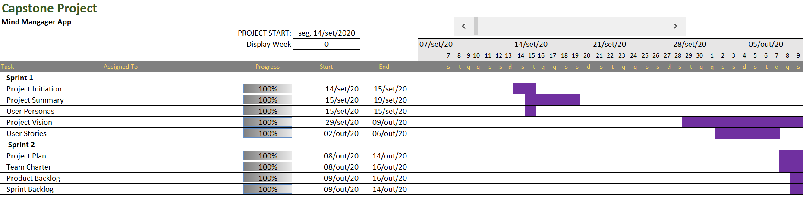
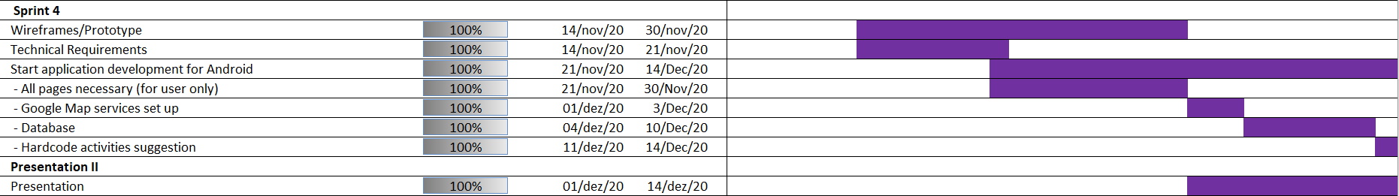

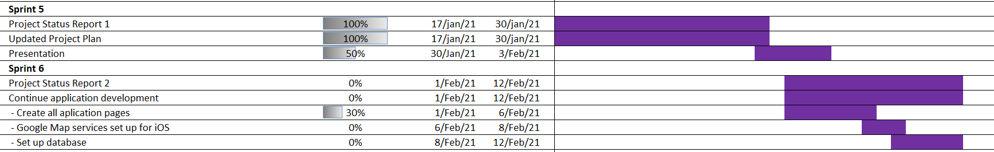
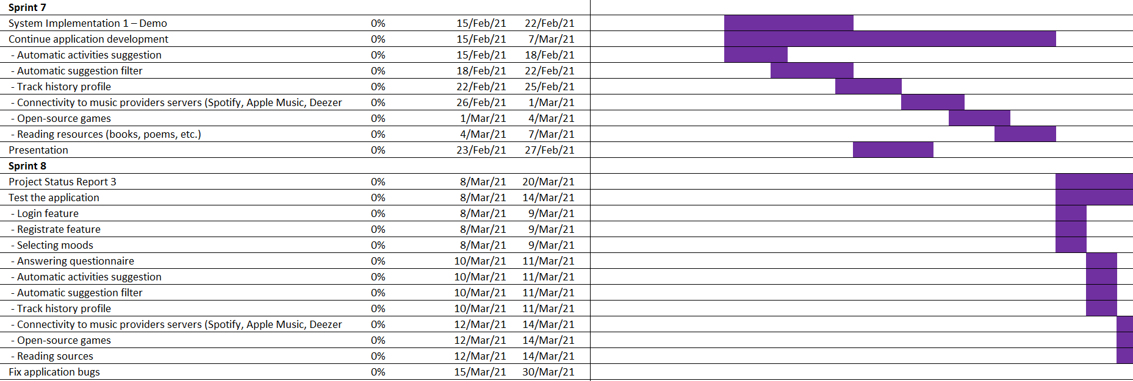

Milestones

Major Activity or Milestone | Estimated Milestone Target date | Owner/Reviewer Team Members
System Requirements and Design Approval | November 05th, 2020 | Bruna Bispo Evgeniya Zhukova Gordon Wells  Karin Zigdon Marina Savochkina
Wireframes/Prototype, Technical Requirements | November 25th, 2020 | Bruna Bispo Evgeniya Zhukova Gordon Wells Karin Zigdon  Marina Savochkina
Start application development | January 15th, 2021 | Bruna Bispo Evgeniya Zhukova Gordon Wells  Karin Zigdon Marina Savochkina
Test the application | March 10th, 2021 | Bruna Bispo Evgeniya Zhukova Gordon Wells Karin Zigdon  Marina Savochkina
Fix application bugs | March 15th, 2021 | Bruna Bispo Evgeniya Zhukova Gordon Wells  Karin Zigdon Marina Savochkina
Application release | April 02th, 2021 | Bruna Bispo Evgeniya Zhukova Gordon Wells Karin Zigdon  Marina Savochkina

RAM – Responsibility Assignment Matrix
Project Team Responsibilities
Project Name: Mind Manager App
Project Manager: Anjana Shah
Task / Person | Bruna | Evgenyia | Gordon | Karin | Marina
Planning | P | P | P | P | P
Designing |  | P | S |  | P
Developing | P |  |  | P | S
Testing | S |  | P
Debugging |  | S |  | P | S
Release | P | P | P | P | P
Maintenance | P |  |  | S

Code: | Stands For:
P | Primary
S | Secondary

Approval
The signatures below indicate their approval of the contents of this document.

Project Role | Name | Signature | Date
Developer | Bruna Bispo | Bruna Bispo | 01/27/2021
Marketing Analyst | Evgenyia Zhukova | Evgenyia Zhukova | 01/27/2021
System Analyst | Gordon Wels | Gordon Wels | 01/27/2021
Developer | Karin Zigdon | Karin Zigdon | 01/27/2021
Developer | Marina Savochkina | Marina Savochkina | 01/27/2021

